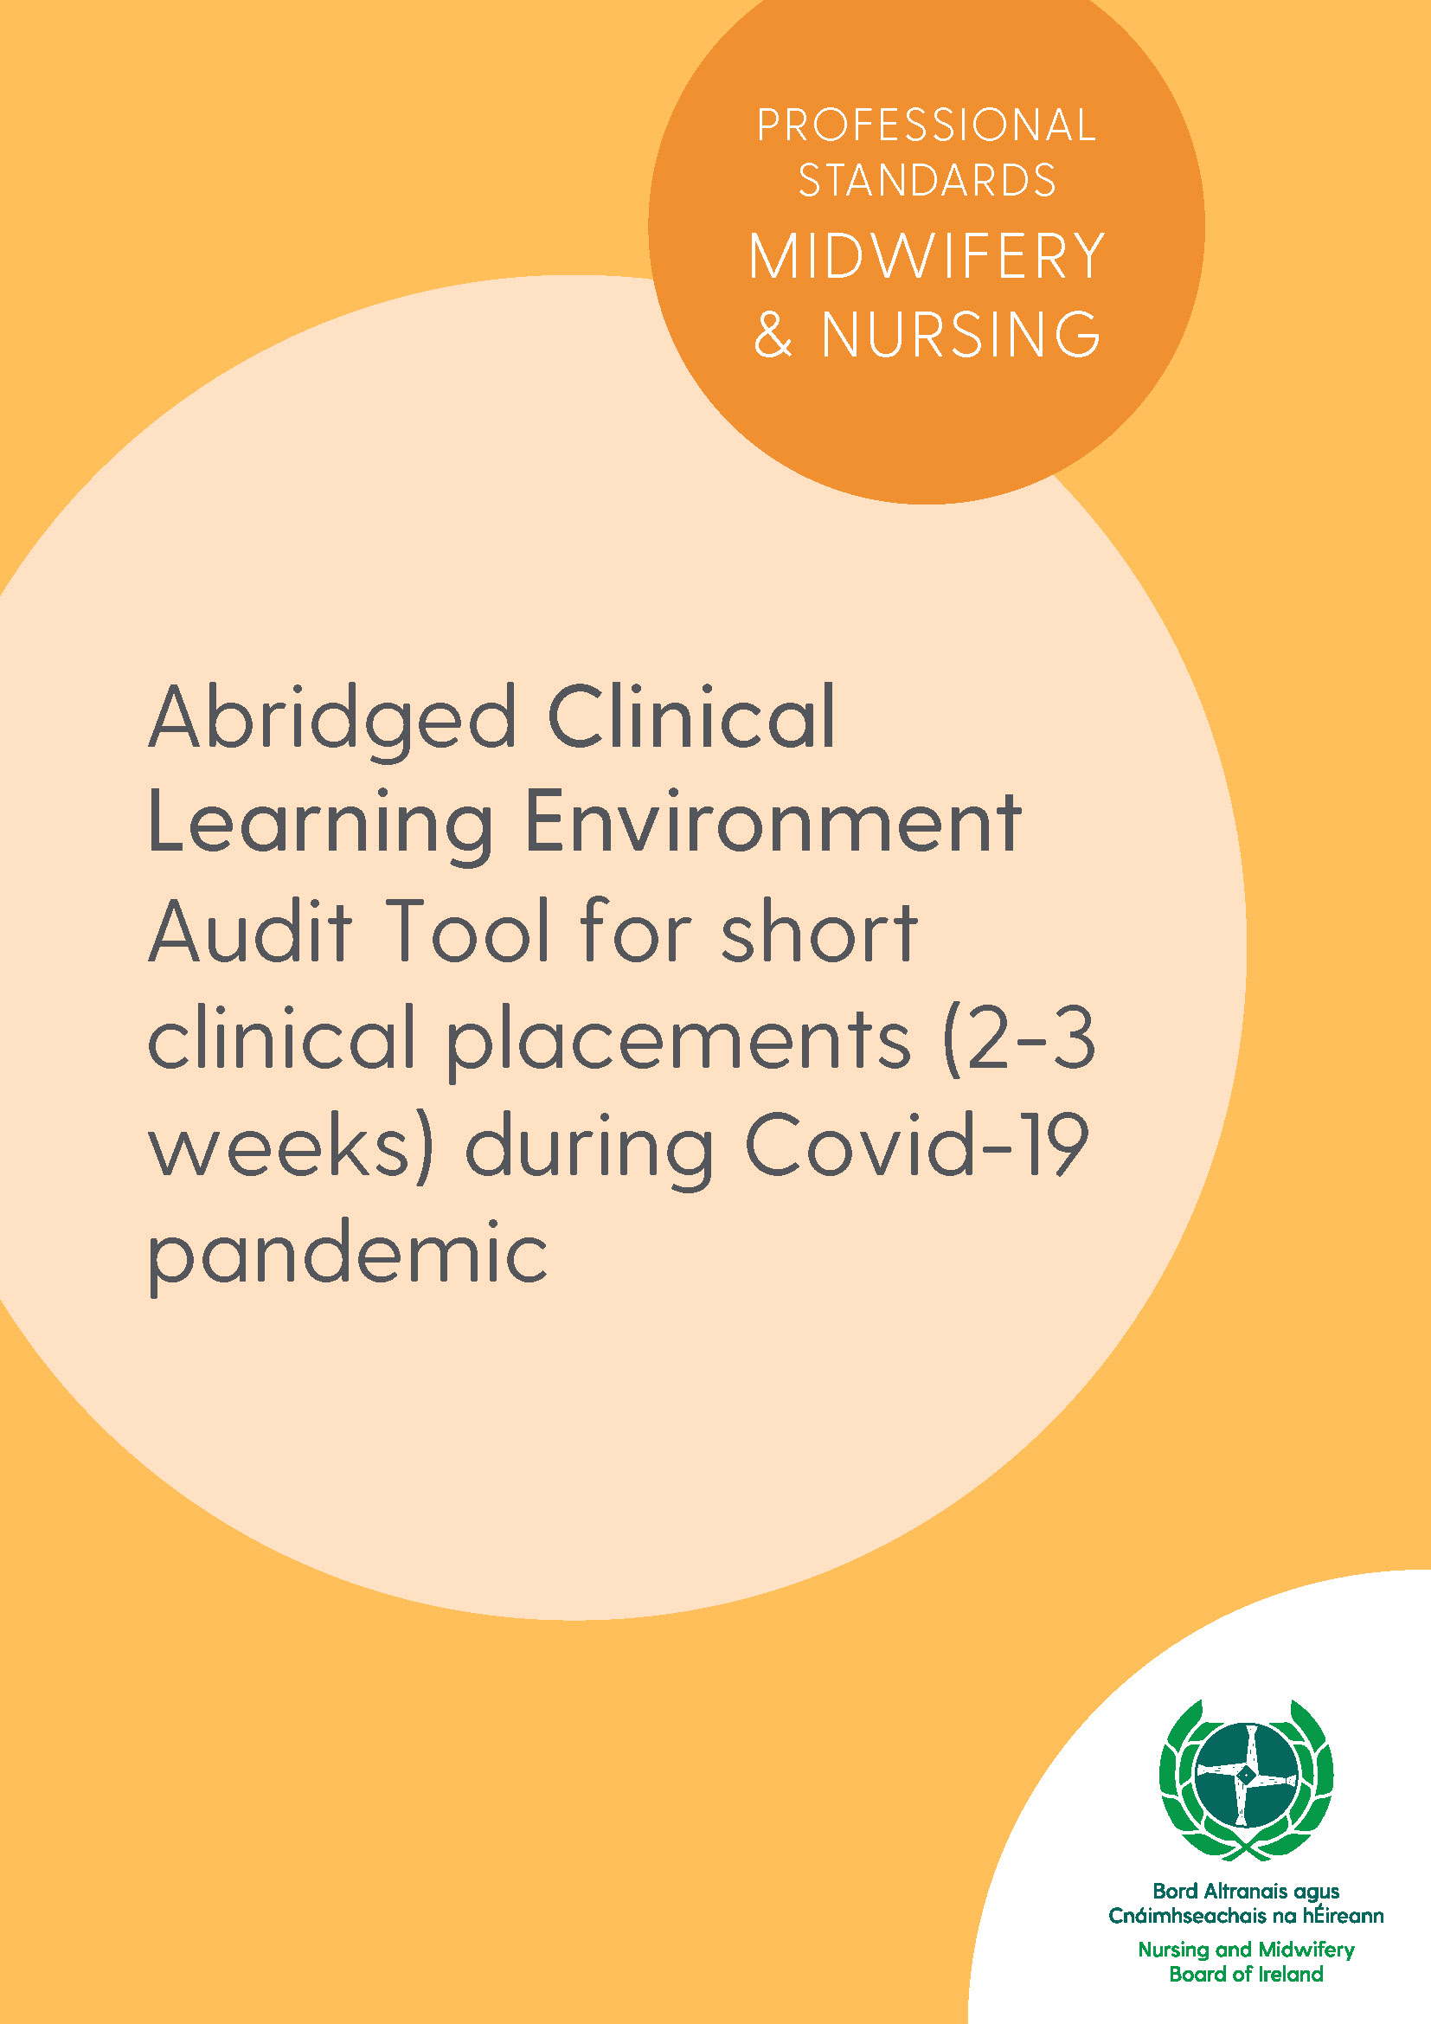

This clinical learning environment (CLE) audit tool is for use in all AHCPs where pre-registration nursing and midwifery students are placed during a short placement training (2-3 weeks). It may be completed by paper-based or online/electronic methods. The audit is undertaken collaboratively between the delegated persons in the HEIs and AHCPs.
Name of associated health care provider/s (AHCPs)
Name of clinical placement
Name of higher education institution (HEI)
Name of the clinical placement coordinator
Name of clinical nurse/midwife manager
Name of HEI link lecturer (LL)
Date of audit
Audit completed by (AHCP: Name and title)
Please provide a brief description of the practice placement and services offered. For example, numbers and type of clients and the range of activities and learning opportunities. (Placement profile can be attached to this document)

3.2.6 Practice Placements & 3.2.7 Practice Placements Learning Environment and Competence Assessment

Standard(s)
Practice placement experience is selected by the Education Body in partnership with its AHCP(s) to support the curriculum aims in accordance with EU Directives and NMBI Standards and Requirements. The preceptors and assessors of nursing/midwifery students’ practice-based learning are appropriately qualified and adequately prepared for and supported in the role of student supervision and identifying areas of learning opportunities towards the assessment of proficiency competence in nursing/midwifery practice. The Clinical Placement Coordinators (where appropriate) also support the role of guidance, facilitation, and monitoring of practice-based learning among undergraduate nursing/midwifery students.
Reference: (Nursing and Midwifery Board of Ireland (2016) Nurse Registration Programmes Standards and Requirements (Fourth Edition). Nursing and Midwifery Board of Ireland: Dublin, Ireland)
 | Indicators
1. | The short clinical practice placement is based in health care institution, community and primary care area that is the subject of audit for their suitability as a quality learning environment to support the achievement of the learning outcomes. This commitment is outlined in the Memorandum of Understanding (MOU). | Y ☐ N ☐
2. | Clearly written up-to-date learning outcomes/objectives appropriate to the agreed practice specific competencies are available and accessible to guide each student learning and achievement of required competence. | Y ☐ N ☐
3. | Practice-based learning is supported by adequate numbers of appropriately qualified and prepared practitioners to include the person in charge, preceptors, Clinical Placement Coordinators who are supported by a Nurse/Midwife Practice Development Coordinator (where appropriate). | Y ☐ N ☐
4. | Each student is assigned a named preceptor during practice placements to provide support and supervision. | Y ☐ N ☐
5. | Assessment of the achievement of practice learning and competence development is undertaken in a fair, effective, and transparent manner in accordance with the assessment strategy and NMBI framework. | Y ☐ N ☐
6. | The supernumerary status of the student in years 1-3 is explicit for preceptors and nursing/midwifery students. | Y ☐ N ☐
7. | Specific periods of protected time, a minimum of four hours, are allocated for reflection during supernumerary placements and the final internship clinical placement (Nurse Education Forum 2000) and is agreed formally between the Education Body and the AHCPs and included in the MOU (Circular 46/2004, Department of Health and Children 2004). | Y ☐ N ☐
8. | Where learning opportunities occur under the supervision of preceptor/s who are members of the multidisciplinary team, allied health, educational and social care professionals, such experiences are monitored by a registered nurse/midwife, link lecturer and the placement’s final assessment process allows for the involvement of a registered nurse/midwife, link lecturer if/as required. | Y ☐ N ☐
9. | There is a process in place for students to evaluate their clinical placements. | Y ☐ N ☐
10. | The AHCPs operate an effective mechanism for the protection of the public and the safety of the vulnerable person receiving healthcare. | Y ☐ N ☐
11. | The AHCPs operate robust processes for managing health problems encountered by students. | Y ☐ N ☐

