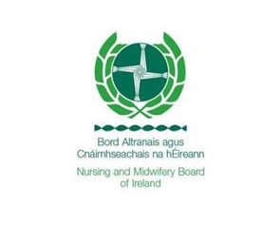

Nursing & Midwifery— QQI FET/FETAC Entry Route
Quality and Qualifications (QQI) was established in 2012 under the Qualifications and Quality Assurance (Education
and Training) Act 2012 replacing FETAC, HETAC, NQAI and incorporating the functions of IUQB.

QQI determine standards for further education and training awards. These awards are branded as a ‘QQI award’. These courses are placed at level 5 or 6 on the National Frame Work of Qualifications.
To become a registered nurse or midwife you must complete a BSc level 8 honours degree in the relevant discipline (approved by the NMBI). It is possible to enter this course through the QQI FET/FETAC entry route rather than leaving certificate points. You must complete a specific QQI courses. These courses are;
Nursing Studies (5M4349) Level 5 Healthcare Support (5M4339) Level 5
Community and Health Services (5M4468) Level 5
Health Service Skills (5M3782) Level 5
To find further education colleges that provide these courses you can search the Qualifax database here: http://www.qualifax.ie/index.php?option=com_wrapper&view=wrapper&Itemid=194
Applicants must achieve at least five distinctions in modules including;
- Anatomy and Physiology (5N0749/D20001)
- Nursing Theory (5N4325)
- Human Growth and Development (5N1279) or Biology (5N2746)
You should be aware that while you may meet the eligibility requirements, there is no guarantee that you will be offered a place. Due to a very small number of places available, a random selection system is operated by the CAO. In recent years, application numbers greatly exceed places available.
Some institutions offering pre-registration honours degree programmes in nursing/midwifery keep a certain amount of places/quotas for QQI FET/FETAC applications. These institutions and their quotas can be accessed on the CAO website at http://www2.cao.ie/fetac/FETACNursingQuota.pdf .
In 2019 151 places were offered to QQI FET/FETAC applicants.

